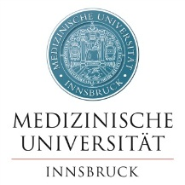
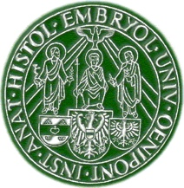
14th International
Cadaver Workshop
INNSBRUCK 2022

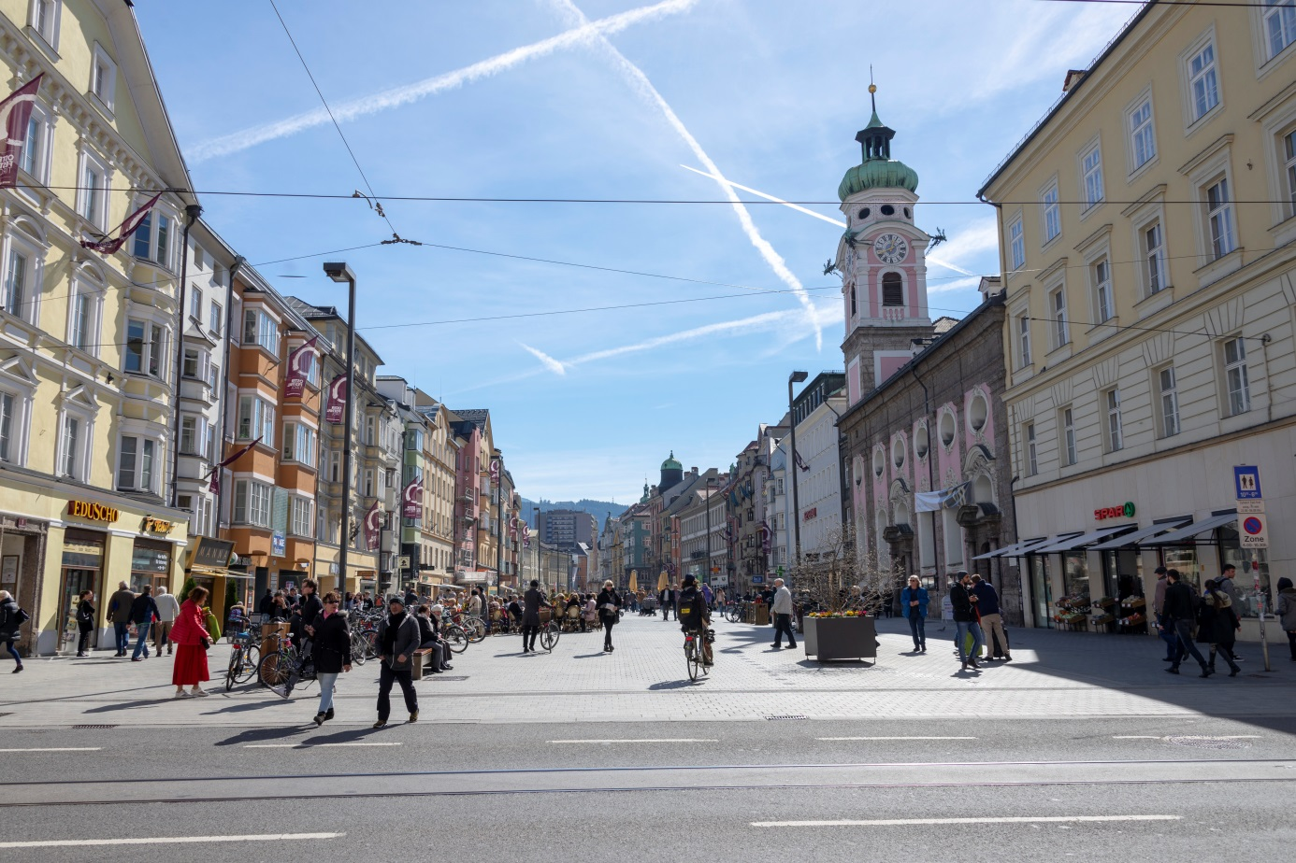

US-Application in Regional
Anaesthesia and Pain Medicine (incl. MSK)
April 29 – 30, 2022
Innsbruck, Austria
Institute of Clinical and Functional Anatomy
Medical University of Innsbruck (MUI)
Innsbruck, Austria

Program Overview
Friday, April 29, 2022
08:00 Registration: Raised ground floor of Department, follow SIGNS!
08:45 Welcome and opening remarks: “INTRO“: Lecture Hall 2nd Floor, LH (Moriggl)
09:00 Introductory affairs: (Chair: Kirchmair)
09:00 Anatomy and US: “DEATHLESS ALIFE”: LH (Moriggl)
09:15 The teaching model: “AS GOOD AS IT GETS”: LH (Moriggl)
09:30 Live demonstration and dialogue: “LIFELESS MEETS LIVING”: LH (Moriggl/BØrglum/Hardman/Lorenzana/Stogicza/Thottungal/Wirthmüller/Behr)

10:20 Morning BREAK: Cafeteria – visit Exhibitors: Dissection Room East, DRE
10:50 Start climbing the stairs: (Chair: Fichtner-Bendtsen)
10:50 Organizing remarks: “STEADY, GET READY”: LH (Moriggl/Nardin)
11:10 Workshop I: “NO FEAR, GET NEAR”: Dissection Room Central, DRC
(Workshop tutors: all Faculty; Supervisor: Moriggl)

13:00 LUNCH: Cafeteria - also visit DRE
14:00 Continue the matter! Supervisor: Moriggl
14:00 Workshop II: “DON’T BE SHY, JUST TRY!”: DRC (all Faculty)
15:45 Workshop III: “GO AHEAD WITH THE DEAD”: DRC (all Faculty)
17:00 DRINK with bites: (Intro by TBA) give feedback, put questions,
get answers: DRE
19:30 Social evening: ALL join together in ULTRA-cosy atmosphere for a
SOUND and unforgettable event

Saturday, April 30, 2022
08:00 Final effort, even better! Supervisor: Moriggl
08:00 Workshop IV: “BLOCK AROUND THE CLOCK……”: DRC (all Faculty)
10:45 Kind of BRUNCH: Cafeteria – visit DRE
11:15 Time to say good-bye! (Chair: Reddy)
11:15 Ultimate lecture: “AN OPTIMUM VIATICUM”: Anatomical Theatre (Greher)
12:00 Closing remarks, farewell: “NO PAIN IN VAIN” (Moriggl)

